AMDAHL’S LAW

Amdahl's law, also known as Amdahl's argument, is named after computer architect Gene Amdahl, and is used to find the maximum expected improvement to an overall system when only part of the system is improved. It is often used in parallel computing to predict the theoretical maximum speedup using multiple processors.
The speedup of a program using multiple processors in parallel computing is limited by the time needed for the sequential fraction of the program. For example, if a program needs 20 hours using a single processor core, and a particular portion of 1 hour cannot be parallelized, while the remaining promising portion of 19 hours (95%) can be parallelized, then regardless of how many processors we devote to a parallelized execution of this program, the minimum execution time cannot be less than that critical 1 hour. Hence the speed up is limited up to 20×, as the diagram illustrates.

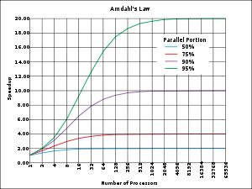

Description
Amdahl's law is a model for the relationship between the expected speedup of parallelized implementations of an algorithm relative to the serial algorithm, under the assumption that the problem size remains the same when parallelized.
For example, if for a given problem size a parallelized implementation of an algorithm can run 12% of the algorithm's operations arbitrarily quickly (while the remaining 88% of the operations are not parallelizable), Amdahl's law states that the maximum speedup of the parallelized version is 1/(1 – 0.12) = 1.136 times faster than the non-parallelized implementation.
More technically, the law is concerned with the speedup achievable from an improvement to a computation that affects a proportion P of that computation where the improvement has a speedup of S. (For example, if an improvement can speed up 30% of the computation, P will be 0.3; if the improvement makes the portion affected twice as fast, S will be 2.) Amdahl's law states that the overall speedup of applying the improvement will be
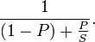
To see how this formula was derived, assume that the running time of the old computation was 1, for some unit of time. The running time of the new computation will be the length of time the unimproved fraction takes, (which is 1 − P), plus the length of time the improved fraction takes. The length of time for the improved part of the computation is the length of the improved part's former running time divided by the speedup, making the length of time of the improved part P/S. The final speedup is computed by dividing the old running time by the new running time, which is what the above formula does.
Here's another example. We are given a task which is split up into four parts: P1 = 11%, P2 = 18%, P3 = 23%, P4 = 48%, which add up to 100%. Then we say P1 is not sped up, so S1 = 1 or 100%, P2 is sped up 5×, so S2 = 500%, P3 is sped up 20×, so S3 = 2000%, and P4 is sped up 1.6×, so S4 = 160%. By using the formula P1/S1 + P2/S2 + P3/S3 + P4/S4, we find the running time is
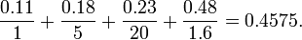
or a little less than ½ the original running time which we know is 1. Therefore the overall speed boost is 1 / 0.4575 = 2.186 or a little more than double the original speed using the formula (P1/S1 + P2/S2 + P3/S3 + P4/S4)−1. Notice how the 20× and 5× speedup don't have much effect on the overall speed boost and running time when 11% is not sped up, and 48% is sped up by 1.6×.

Parallelization
In the case of parallelization, Amdahl's law states that if P is the proportion of a program that can be made parallel (i.e. benefit from parallelization), and (1 − P) is the proportion that cannot be parallelized (remains serial), then the maximum speedup that can be achieved by using N processors is
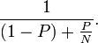
In the limit, as N tends to infinity, the maximum speedup tends to 1 / (1 − P). In practice, performance to price ratio falls rapidly as N is increased once there is even a small component of (1 − P).
As an example, if P is 90%, then (1 − P) is 10%, and the problem can be speed up by a maximum of a factor of 10, no matter how large the value of N used. For this reason, parallel computing is only useful for either small numbers of processors, or problems with very high values of P: so-called embarrassingly parallel problems. A great part of the craft of parallel programming consists of attempting to reduce the component (1 – P) to the smallest possible value.
P can be estimated by using the measured speedup SU on a specific number of processors NP using
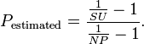
P estimated in this way can then be used in Amdahl's law to predict speedup for a different number of processors.

Speedup in a sequential program
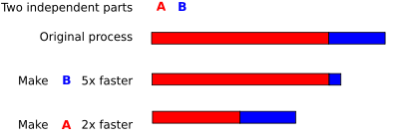
Assume that a task has two independent parts, A and B. B takes roughly 25% of the time of the whole computation. By working very hard, one may be able to make this part 5 times faster, but this only reduces the time for the whole computation by a little. In contrast, one may need to perform less work to make part A be twice as fast. This will make the computation much faster than by optimizing part B, even though B speed-up by a greater ratio, (5× versus 2×).
The maximum speedup in an improved sequential program, where some part was sped up p times is limited by inequality
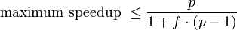
where f (0 < f < 1) is the fraction of time (before the improvement) spent in the part that was not improved. For example (see picture on right):
If part B is made five times faster (p = 5), tA = 3, tB = 1 and f = tA / (tA + tB) = 0.75, then
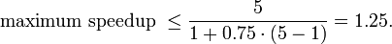
If part A is made to run twice as fast (p = 2), tB = 1, tA = 3 and f = tB / (tA + tB) = 0.25, then
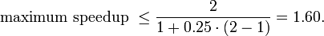
Therefore, making A twice as fast is better than making B five times faster. The percentage improvement in speed can be calculated as
Improving part A by a factor of two will increase overall program speed by a factor of 1.6, which makes it 37.5% faster than the original computation.
However, improving part B by a factor of five, which presumably requires more effort, will only achieve an overall speedup factor of 1.25, which makes it 20% faster.

